Course Content for Product Development - 14 March to 21 March 2020
Topic 1: Morphology of Design.
Morphology means ‘a study of form or structure'. Morphology of design refers to the time based sequencing of design operations. It is a methodology of design by which ideas about things are converted into physical objects. The logical order of different activities or phases in a design project is called the morphology of design.
Design Process- Simplified Approach
A simplified approach to designing as outlined by Morris Asimow is given below. According to him the entire design process in its basic forms consists of five basic elements as given below.
Detailed Morphology of Design
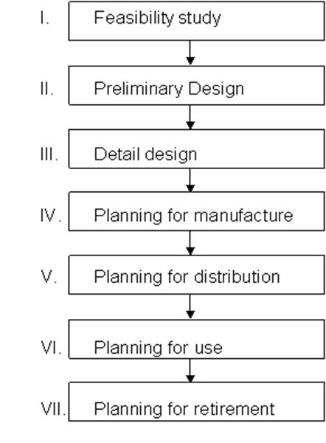

A design project goes through a number of time phases. Morphology of design refers to the collection of these time phases. The morphology of design as put forward by Morris Asimow can be elaborated as given below. It consists of seven phases.
Phase 1. Feasibility Study.
This stage is also called conceptual design. A design project always begins with a feasibility study. The purpose and activities during feasibility study are
• To ascertain there really exists a need [ie the existence of need must be supported by necessary evidences, rather than the outcome of one's fancy]
• Search for a number of possible solutions
• Evaluate the solutions
i.e. is it physically realizable?
Is it economically worthwhile?
Is it within our financial capacity?
Phase 2 Preliminary (Embodiment) Design.
This is the stage art which the concept generated in the feasibility study is carefully developed. The important activities done at this stage are:
• Model building & testing
• Study the advantages and disadvantages of different solutions.
• Check for performance, quality strength, aesthetics etc.

Phase III: Detail Design
Its purpose is to furnish the complete engineering description of the tested product. The arrangement, from, dimensions, tolerances and surface properties of all individual parts are determined. Also, the materials to be used and the manufacturing process to be adopted etc. are decided. Finally, complete prototype is tested.
Phase IV: Planning for manufacture
This phase includes all the production planning and control activities necessary for the manufacture of the product. The main tasks at this phase are
• Preparation of process sheet, i.e. the document containing a sequential list of manufacturing processes.
• Specify the condition of row materials.
• Specify tools & machine requirements.
• Estimation of production cost.
• Specify the requirement in the plant.
• Planning QC systems.
• Planning for production control.
• Planning for information flow system etc.
Phase V: Planning for Distribution
The economic success of a design depends on the skill exercised in marketing. Hence, this phase aims at planning an effective distribution system. Different activities of this phase are
• Designing the packing of the product.
• Planning effective and economic warehousing systems.
• Planning advertisement techniques
• Designing the product for effective distribution in the prevailing conditions.
Phase VI Planning for Consumption/use
The purpose of this phase is to incorporate in the design all necessary user- oriented features. The various steps are
• Design for maintenance
• Design for reliability
• Design for convenience in use
• Design for aesthetic features
• Design for prolonged life
• Design for product improvement on the basis of service data.
Phase VII: Planning for Retirement.
This is the phase that takes into account when the product has reached the end of useful life. A product may retire when
• It does not function properly
• Another competitive design emerges
• Changes of taste or fashion
The various steps in this phase are
• Design for several levels of use
• Design to reduce the rate of obsolescence.
• Examine service-terminated products to obtain useful information.

Topic 2: IDENTIFICATION OF NEED
A need can be defined as a personnel unfulfilled vacancy which determines and organizes all psychological and behavioral activities in the direction of fulfilling the vacancy
A product can be product and marketed only if it is ‘needed' by the customer. A person buys a pen because he ‘needs' to write. A patient ‘needs' something that can cure his illness. These examples show that needs are nothing but a scarcity or problem or wants felt by a person, device or a system. In fact a designer's goal is to find solutions to such problems
Hierarchy of Human needs
Maslow developed a hierarchy of human needs as given below
1. Physiological needs
- These are the basic needs of the body- For example, thirst, hunger, sex, sleep etc.
2. Safety and security needs
For a person whose physiological needs are met, the new emerging needs are safety needs. These include, protection against danger, threat etc.
3. Social needs
Once the physiological and safety needs are met, the next dominant need is social need. For example he/she want to love and be loved, he want to be “in group”, etc.
4. Psychological needs
These are the needs for self-respect and self- esteem, and for recognition.
5. Self-fulfillment needs
These are the needs for the realization of one's full potential through self-development, creativity, and self-expression.
Identification/Recognition of Needs
The beginning of any design process is the recognition of need or problem. When a turner hears an awkward noise from some part of the lathe he identifies/ recognizes a need. I.e. the lathe requires repair. When the sales personnel observes that their customers are always complaining of poor performance of the products, a need to develop a better product is identified. Similarly, when the customers are unsatisfied with the present ‘model', a new need is recognized.
Needs can be identified from,
• Careful market analysis
• Statements made by politicians from their observations
• Interpretations of a community's requirements
• Trends in other parts of the world
4.4. Variety of Needs [S'00]
Following are the needs, which can generate ideas for the development of new products.
(i). Variation of an existing product.
This could be a change in a single or a few parameters of an existing product.
Eg - Changing the length of a cylinder.
-Changing the power of a motor, etc.
• Improvements in the existing product.
This implies the need to redesign some of the features of an existing product. Such needs can arise, when
-Customers want a new feature or better performance than existing features
-A vendor can no longer supply components or materials that had been used so far
-Manufacturing or assembly departments identifies a quality improvement
-Invention of a new technology that can be incorporated in the existing design.
(iii) A change in production model
Whenever the production model changes from job-shop to mass, a corresponding change in product design may be demanded. For example, there is more tendency to buy off-the shelf components for short-run products.
Whatever may be the situation, a company has to identify or locate a need before the production of any device. This crucial step is called Recognition/ Identification of need.
Examples:
1. With the free-entry of Chinese products to Indian market, manufacturers in India recognize a need to sell their products at a lower price.
2. When a company observes that their products do not perform well, the company recognizes a need to re-design it.
Need Statement: Once the need has recognized, the next step is to prepare the need statement. It is a general statement specifying the problem for which a solution is required. In other words-It is the objective of design, expressed in the form of a statement.
i). Bicycle: - The need statement for a bicycle could be “A device for a common person to travel reasonable distance comfortably with least effort” –“The initial cost should be low- and be as light as possible, have adequate life, be easy to maintain etc “
(ii). Voltage stabilizer “A solid state noiseless electrical device of adequate power rating to provide continuously an output at constant voltage, accepting the input power at varying voltage between the limits__and__volts “. The indications for input and output voltage levels may be provided.
iii). Personnel Computer “A computing device to accept input data, manipulate it according to a set of instructions and provide the desired output o n CRT and printer”

