WORK STUDY DEPARTMENT
Work Study Department must be given a high position in a factory, so that the persons working in the department cannot be influenced by the officers working on the floor and their suggestions can be accepted with respect and acted upon.
Work Study Department generally works as a part of the Industrial Engineering Depart­ment. Since the Industrial Engineering Department is for the service of the management of an enterprise, therefore, it must be a staff and not a line activity.
The position of the head of the Industrial Engineering Department in relation to his fellow members of the staff depends upon following important factors:
(i) Size of the organisation.
(ii) Type of organisation and whether managed by owner himself or by professionals.
(iii) Nature of work carried out in the factory.
(iv)Qualifications, experience personality etc. of the Chief Industrial Engineer and those of other departmental heads.
Looking to above factors, there cannot be any standard chart for organisational structure. A typical organisation chart showing the position of Industrial Engineering Department is given as under.
Sometimes Chief Industrial Engineer is given a place under General Manager Works. It is due to the reason that he is responsible to increase the overall productivity and by putting the Industrial Engineering Department under him, he can give more importance to the suggestions or advices placed before him.
In such case, the organisational structure will be similar to that shown in the chart below:

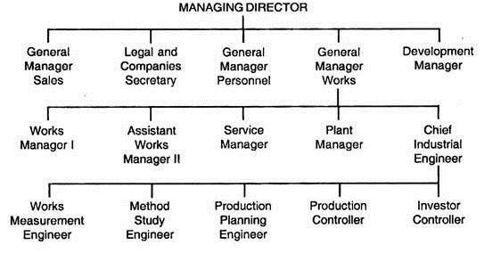
Quality of Work Study Man:
Certain qualities are expected from a work study man, however they vary from work to work. Here some of the required qualities are explained.
(A) Qualifications Abilities:
(i) Good knowledge of work study techniques.
(ii) Good knowledge of different manufacturing process for which he is conducting the work study.
(iii) He must be well qualified and sufficiently trained.
(B) Mental Abilities:
(i) Mentally prepared and interested to do that work.
(ii) Good observation power, i.e. mental alertness, quick to notice.
(iii) A man of clear thoughts.
(iv) Power to express things clearly.
(C) Personal Qualities:
(i) Sincere and honest, so as to gain the confidence and respect of those with whom he had to deal.
(ii) He must have enthusiasm.
(Iii) Tactful in handling the situation.
(iv) Self-confidence, strong will power and courage.
(v) Leadership capabilities.
Good Relations for Work Study:
One of the greatest difficulties in obtaining the active cooperation of the workers is the fear that increasing the productivity will lead to their unemployment. Therefore, before introducing the work study, relations between the management and the workers must be reasonably good and the workers must have confidence in the sincerity of the management towards them. In the absence of good relations, workers will consider it as a trick to get more work out of them without giving any benefit.
The second main difficulty is that, due to the general conservatism of human beings, any change in existing methods and practices is an interruption of a comfortable situation in which well-established routines have been set up.
The third important difficulty is that, when work study team work in a plant, it appears that it has taken up management’s role. The sitting managers do not like it and feel that their positions have been illegally seized. Therefore, it is necessary to know how the good relations with the workers on one side and with the management on the other side can be maintained.

