Quality Function deployment
Quality function deployment (QFD) is a planning and problem-solving tool that is used from transforming customer requirement into the engineering characteristics of the product. QFD helps to transform the customer needs (also referred to as voice of customer) into engineering characteristics (and appropriate test methods) for a product. It is a graphical technique, which systematically looks at all the elements that are deemed important based on customers survey go into the production definitions. A sample layout of the QFD diagram is shown below. 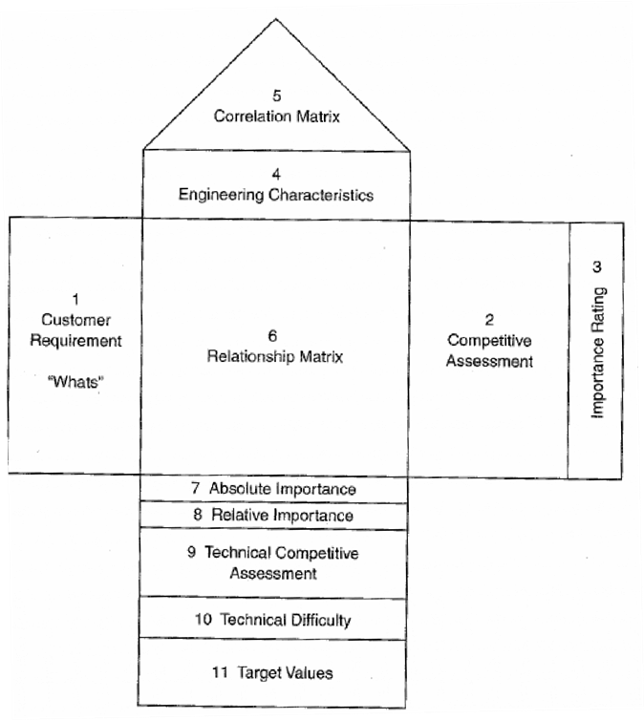
Figure 1.1.2 Schematic presentation of quality function deployment (QFD) house / table Following are a brief outline of each section of the quality function deployment table.

Customer requirements (what’s)
These are typically the customer requirements. Competitive assessment
It shows how the top two or three competitive products rank with respect to the customer requirements. This starts with ranking each customer requirements on a scale of 1 to 5 and then by considering planned improvement and any requirements that are planned for special attentions.

Engineering characteristics (how’s)
The engineering characteristics that enable satisfying the customer requirements are listed in this column.
Correlation matrix
It shows the degree of interdependence of the engineering characteristics with each other in the ‘roof of the house’.
Relationship matrix
It represents the correlation between the engineering characteristics and the customer requirements.
Absolute importance
To determine the absolute importance we need to multiply the numerical value in each of the cells of the relationship matrix(6) by the importance rating (3) and then sum the numbers in the cells of each column.
Relative importance
This represents the absolute importance but normalized on a scale of 1 to 100. Technical competitive assessment
This refers to the benchmarking of the company performance against the top two or three competitors for each of the engineering characteristics.
Technical difficulties
These depict the ease (or the extent of difficulty) to achieve each engineering characteristic. Target values
This would depict the final target set based on the key engineering characteristics that are deemed important and the assessment of the technical difficulty.

Product Design Specifications
The product design specification is the basic control and reference document that would include the outcomes of the product development exercise, and is the must to begin with and execute the design and manufacturing of any specific part or product. The quality function deployment tool provides the most crucial inputs in writing the product design specifications. Following are some of the important elements of a typical product design specification document. It is, however, not necessary that the product design specification document of any product will contain all these elements.
[A] In-use purposes and market requirements
(a) Title and Purpose or function of the product,
(b) Predictable unintended use of the product,
(c) Special features of the product,
(d) What would be the competitive products?
(e) What is the indented market and why there is a need for this product?
(f) Relationship of the product to the other company products,
(g) Anticipated market demand (units per year) and target price.
[B] Functional Requirements
(a) Functional performances such as flow of energy, information, materials, operational steps, efficiency, accuracy, etc.,
(b) Physical requirements such as shape, size, weight, surface finish, etc.,
(c) Service environment such as storage and transportation requirement,
(d) Life-cycle issues including useful life, reliability (mean time to failure), robustness, ease of installation, maintenance and repair, recyclability, etc.
(e) Human factors including importance of aesthetics, ergonomics and user-training.
[C] Corporate Constrains
(a) Is there adequate time to design a quality product and its manufacturing process (time to market)
(b) What are the requirements for manufacturing this product?
(c) Do existing relationships with the suppliers pose any constraint on manufacturing?
(d) Are there any constraints in using the trademark, logo, brand name?
(e) What are the profitability and return on investment (ROI) that must be met?

(f) The production team should follow professional ethics at every level of the design process when they are dealing with suppliers, dealers, corporate officials, society etc.
[D] Social, Political and Legal Requirements
(a) The product design specification should meet / contain all the requisite safety and environmental regulations,
(b) The product design specification should contain all the required standards,
(c) The product design specification must be completed with respect to all safety and liability norms,
(d) The product design specification should consider all the information related to the patents and intellectual property that are applicable.
Product Design Specifications (PDS) is explained with the following example in which the PDS is done for an adjustable wheel chair.
Criterion Performance
Requirement Seat width
Primary Customer Patient
Target Basis Market research
Verification Method Prototyping

Similarly, other dimensions of the wheel chair can be set. However, the criteria are not only based on the performance. There can be other criteria as well like aesthetics, life in service, legal (Patents, Product Liability) and so on. One of them is shown below.
Criterion Life in Service
Requirement Appropriate service life for capital asset
Primary Customer Hospitals
Target Basis Market Analysis

References
1. G Dieter, Engineering Design - a materials and processing approach, McGraw Hill, NY, 2000.
2. http://web.cecs.pdx.edu/~far/me491/Sample%20Reports/Keen%20PDS%20Report.pdf.

