Product Life cycle
Every product goes through a cycle from birth, followed by an initial growth stage, a relatively stable matured period, and finally into a declining stage that eventually ends in the death of the product as shown schematically in Figure 1.1.2.
- Introduction stage: In this stage the product is new and the customer acceptance is low and hence the sales are low.
- Growth stage: Knowledge of the product and its capabilities reaches to a growing number of customers.
- Maturity stage: The product is widely acceptable and sales are now stable, and it grows with the same rate as the economy as a whole grows.
- Decline stage: At some point of time the product enters the decline stage. Its sales start decreasing because of a new and a better product has entered the market to fulfill the same customer requirements.

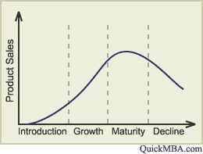
Figure 1.1.2 Schematic outline of a product life cycle

Technology development cycle
The development of a new technology follows a typical S-shaped curve [Figure 1.1.3(a)]. In its early stage, the progress is limited by the lack of ideas. A single good idea can make several other god ideas possible, and the rate of progress is exponential. Gradually the growth becomes linear when the fundamental ideas are in place and the progress is concerned with filling the gaps between, the key ideas. It is during this time when the commercial exploitation flourishes. But with time the technology begins to run dry and increased improvements come with greater difficulty. This matured technology grows slowly and approaches a limit asymptotically. The success of a technology based company lies in its capabilities of recognizing when the core technology on which the company’s products are based begin to mature and through an active R&D program, transfer to another technology growth curve [Figure 1.1.3(b)] which offers greater possibilities.

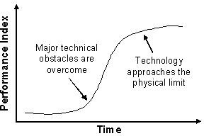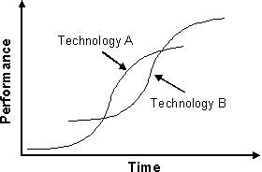
(a)
(b)
Figure 1.1.3 Schematic outline of (a) technology development curve, (b) improved program to develop new technology before the complete extinct of existing technology.

